MANDATORY MEDICAL EXAMINATION
To lawfully reside in the territory of the Russian Federation, foreign students are required to undergo a medical examination within the established timeframe..

Medical examination

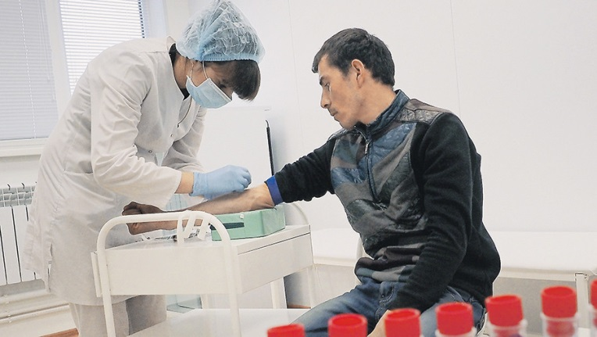

Legal basis: Federal Law No. 162-FZ dated 10.06.2026 “On Amendments to the Federal Law ‘On the Legal Status of Foreign Citizens in the Russian Federation’ and Article 34 of the Federal Law ‘On the Sanitary and Epidemiological Welfare of the Population’” from 1 September 2026.

Who is required to undergo a medical examination?
Foreign citizens who arrive in the Russian Federation for purposes not related to employment for a period exceeding 90 calendar days (including for the purpose of studying) are required to undergo a medical examination. | 

Timeframes for completion:
- Initial medical examination — within 30 calendar days from the date of entry into the Russian Federation.
- Repeat medical examination — annually, within 30 calendar days after one year from the date of the previous medical examination.
- Exception: if a foreign citizen has already undergone a medical examination within the year preceding the date of entry, a repeat initial examination is not required.

Where to undergo a medical examination
A medical examination is carried out only in medical organizations authorized to conduct medical examinations of foreign citizens and located on the territory of the Russian Federation:
- Center for Immigration Assistance and Medical Examination of Immigrants, State Budgetary Healthcare Institution “Volgograd Regional Clinical Psychiatric Hospital No. 2”, Zemlyachki Street, 94, Volgograd; | 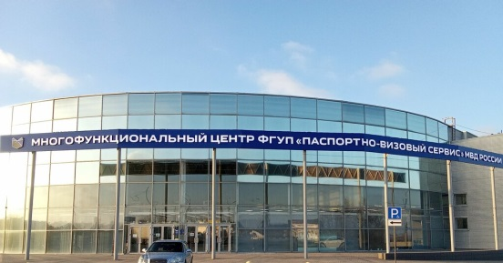
- Family Medicine Clinic, Volgograd State Medical University, KIM St., 20, Volgograd. | 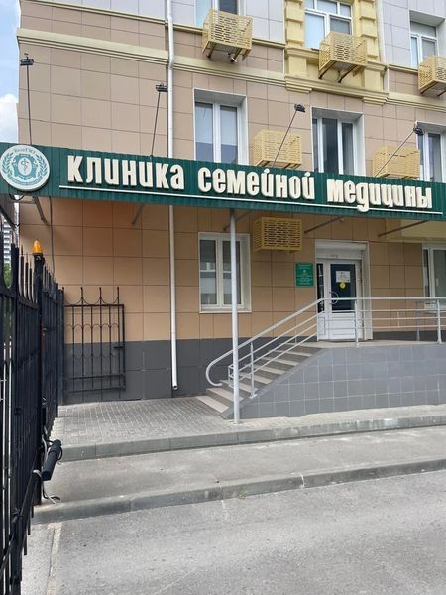
Cost
The medical examination is carried out at the expense of the foreign citizen (or at the expense of the employer — for those who are employed).

What does a medical examination include?
- Checking for the presence or absence of the use of narcotic drugs or psychotropic substances without a doctor’s prescription, or of new potentially dangerous psychoactive substances;
- Identifying infectious diseases that pose a danger to others (according to the list approved by the federal executive authority authorized by the Government of the Russian Federation);
- Identifying HIV infection.

Results of the examination

Based on the results, medical conclusions are drawn up in electronic form:
- regarding the presence (or absence) of the use of narcotic drugs and psychotropic substances;
- regarding the presence (or absence) of infectious diseases that pose a danger to others, and HIV infection.
- regarding the presence (or absence) of HIV infection.

Medical conclusions are generated in the form of electronic documents signed using an enhanced qualified electronic signature by a medical worker and an authorized medical organization; they are posted in the federal register of documents within 24 hours and automatically transmitted:
- to the Ministry of Internal Affairs of Russia (both conclusions);
- to Rospotrebnadzor (if infectious diseases are detected).
A foreign citizen has the right to contact an authorized medical organization with a request for the results and obtain a paper copy of the statement confirming the content of the medical conclusion.
A foreign citizen is required to personally submit the conclusions regarding the repeated medical examination to the Ministry of Internal Affairs.

Consequences of failure to comply:  Failure to comply with the obligation to undergo a medical examination within the established timeframe is grounds for:  - an administrative fine in the amount of 25,000 to 50,000 rubles, with or without administrative expulsion from the Russian Federation.  (Administrative Code of the Russian Federation Article 18.11.1. Refusal and (or) evasion of a foreign citizen or stateless person from fulfilling the obligation to undergo a medical examination) | 

