How do I get to Volgograd State Socio-Pedagogical University from Stalingrad Airport?

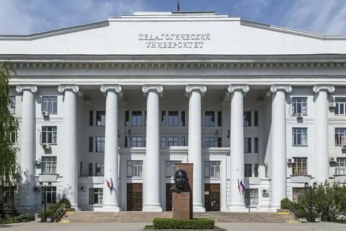
The fastest way to get to the Volgograd State Socio-Pedagogical University (VGSPU), located at 27 V.I. Lenin Avenue, from Stalingrad Airport is by taxi, while the cheapest option is by public transport with a transfer.
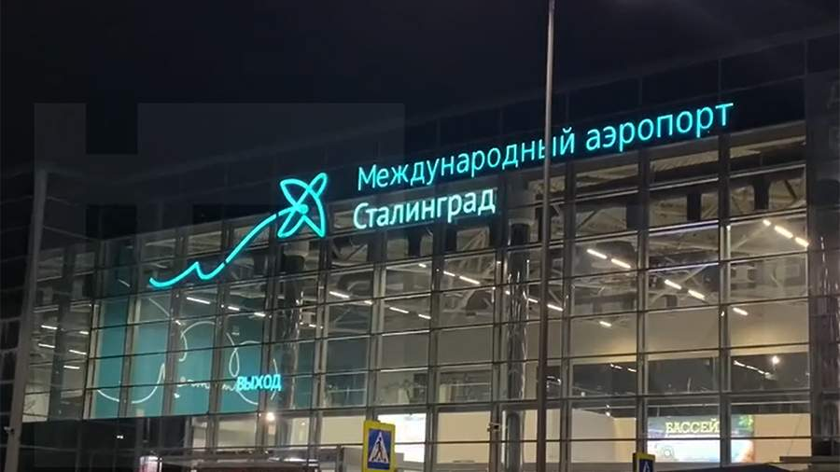

By taxi
You can take a taxi from the ranks near the airport or the station square, or book one via an app:
Yandex Taxi: +7 (8442) 744-444 (or via the YandexGO app: https://taxi.yandex.ru/)
Maxim Taxi: +7 (8442) 500-000, +7 (8442) 300-000 (Website: https://volgograd1.taximaxim.ru/zakazi-taksi-onlajn)

Travel time: approximately 30 minutes.

By public transport
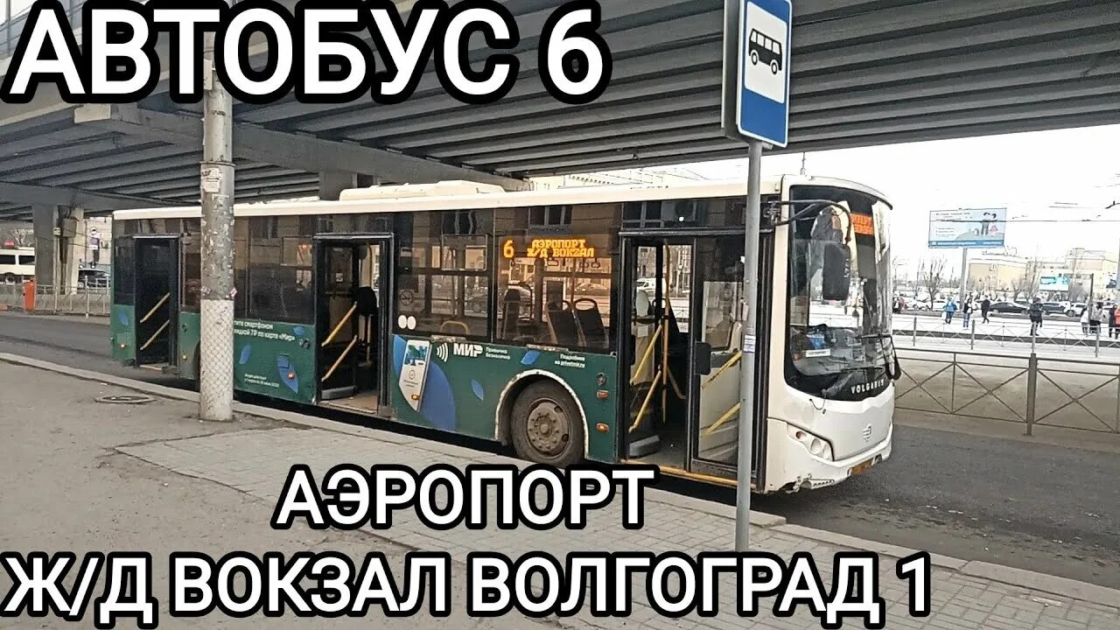

Bus or minibus from the airport:

Take bus No. 6 or a minibus heading to the city center or the railway station (Volgograd-1).

Travel time: approximately 40 minutes.

Железнодорожный вокзал (Волгоград-1).

Switch to public transport or walk to the "Technical University" stop.

