How to get from Moscow to Volgograd
The distance between Moscow and Volgograd is 911 km. You can get to Volgograd by plane, train, or bus..

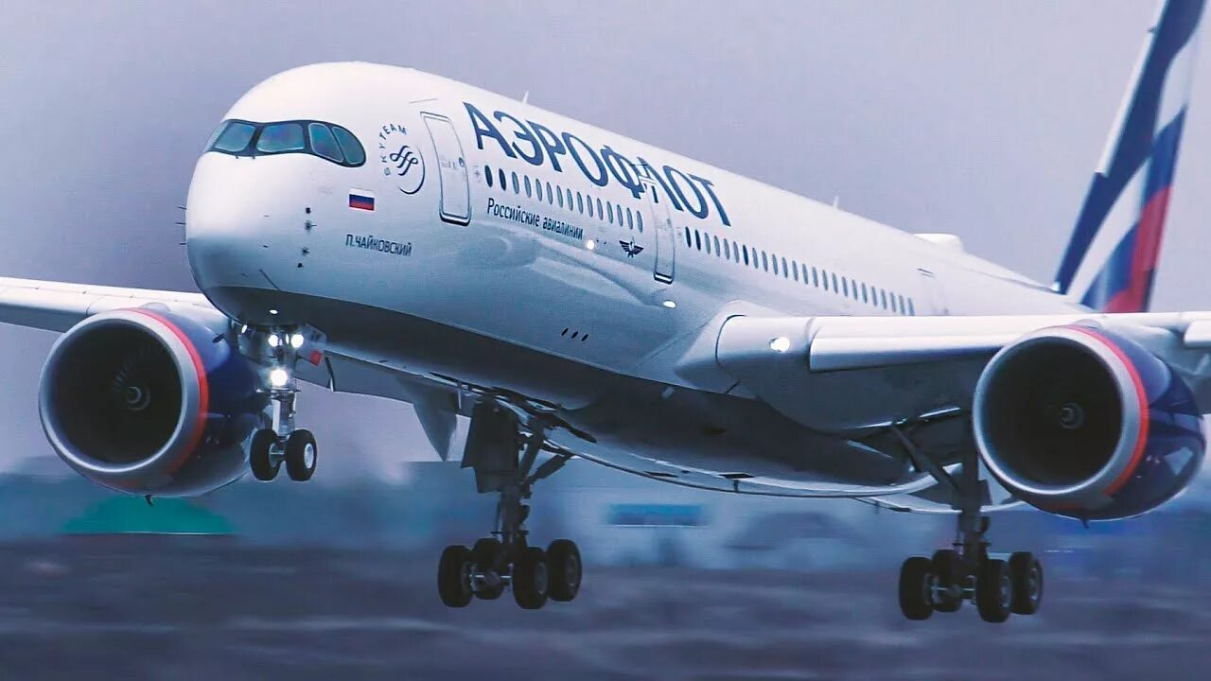

Flying is the fastest option. Flights operate daily from Moscow’s Sheremetyevo and Domodedovo airports, served by Pobeda, S7 Airlines, and Aeroflot. You can check ticket prices and departure times on the airlines' websites::
- http://www.aeroflot.ru,
- https://www.pobeda.aero,
- http://www.s7.ru,
- https://www.aviasales.ru,
- http://www.aviacassa.ru,
- http://www.tutu.ru,
- http://www.ozon.travel.

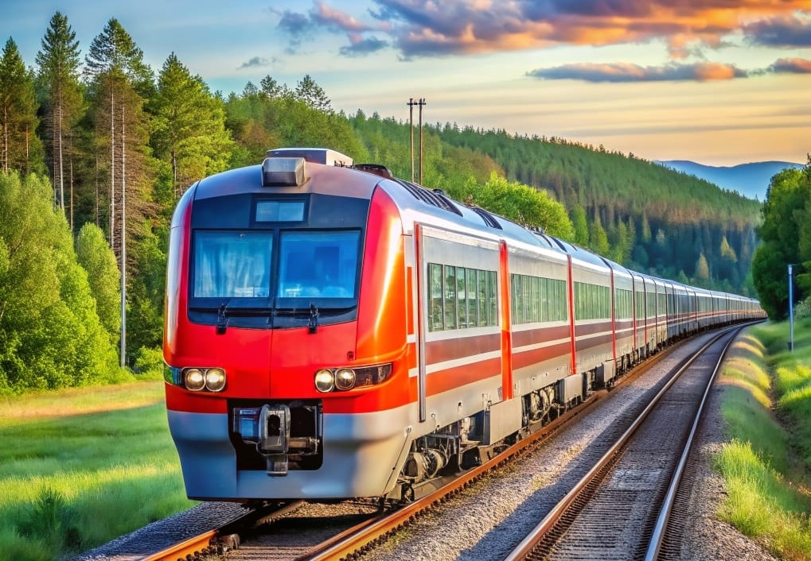
The train journey from Moscow to Volgograd takes an average of 17–21 hours; trains depart from Moscow’s Paveletsky and Vostochny stations and arrive at the Volgograd-1 station. Tickets can be booked on the following websites:
- http://rzd.ru.
  - http://www.tutu.ru.

A bus trip from Moscow to Volgograd takes, on average, between 13.5 and 15 hours.

Buses to Volgograd depart from several bus terminals and stations in Moscow:
• Salaryevo International Bus Terminal,
• Kotelniki Bus Terminal

You can find more detailed information about bus departure times on the websites.:
- http://www.avtovokzaly.ru,
- avtobus/moskva-volgograd.
- https://bus.tutu.ru/raspisanie/gorod_Moskva/gorod_Volgograd/

