SIM Cards for Foreign Citizens
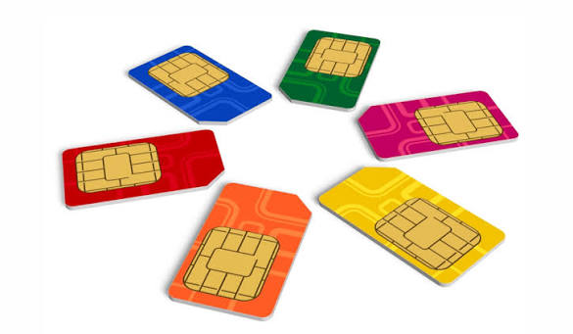
On 1 January 2025, Russia introduced stricter rules for foreign citizens purchasing SIM cards.
- The contract can now only be concluded in person at a mobile phone store.
- A foreigner may have no more than 10 SIM cards, including corporate numbers.
- To receive communication services, SNILS, a Gosuslugi account, and biometrics will be required.
- Each contract will contain a unique device number — IMEI.

1. Prepare the necessary documents and data
- Identity document
- Notarized translation of the foreign citizen’s passport
- Email address

2. Obtain SNILS
Contact an MFC office or a Social Fund branch with your documents and application.
SNILS will be issued in paper or digital form within 5 days.
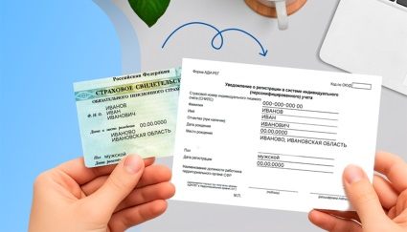
Bring with you:
- Identity document
- Notarized translation of the passport
- Email address to which you have access

3. Register on the Gosuslugi portal

Contact an MFC or a bank branch to create an account on the Gosuslugi portal..
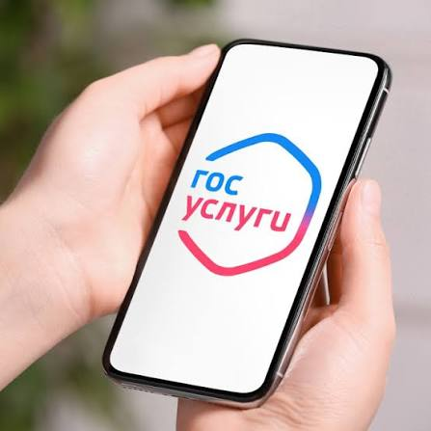
Bring with you:
- Identity document
- Notarized translation of the passport
- SNILS

4. Register biometrics at a bank
Contact a bank branch to register in the Unified Biometric System.
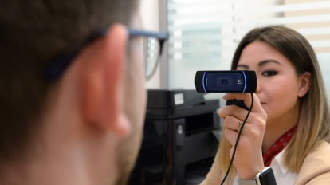
Bring with you:
- Identity document
- Notarized translation of the passport
- SNILS

5. Purchase a SIM card at a mobile phone store

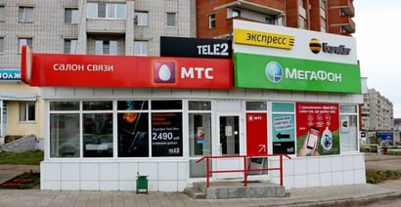
Conclude a contract with the mobile operator. Activate the SIM card at the operator’s office or independently on Gosuslugi. Provide the IMEI — the number of your device.
Bring with you:
- Identity document
- Notarized translation of the passport into Russian
- Identity document — for a stateless person
- SNILS
- Confirmed Gosuslugi account
- Confirmed biometrics
- Email address to which you have access
- IMEI of the device in which you plan to use the SIM card


Useful information

Identity document
- For a foreigner — foreign citizen’s passport
- For a stateless person:
  - residence permit
  - refugee certificate
  - temporary residence permit

Email address for registration on Gosuslugi
To register on Gosuslugi without a phone number, any email address is required. There are no restrictions on registering with a foreign email address.
With a Russian or foreign phone number, registration is available in the email services Yandex, Mail, and VK Mail.

Notarized translation of a foreign citizen’s passport
This is required if the passport does not contain a translation into English of the surname, first name, and patronymic — if present.
To arrange a translation, contact:
- a notary — have the translation done by a translator recommended by the notary and have the document certified
- a translation bureau

SNILS is the insurance number of an individual personal account. SNILS is assigned once to every citizen by the Social Fund (SFR) and consists of 11 digits.
SNILS does not change even if documents are lost or personal data changes.
SNILS is also used for registration on Gosuslugi and on departmental websites.
SNILS is a digital document. It has no physical medium — it is enough to know the number.
IMEI (International Mobile Equipment Identity) — the number of your device.

How to find the IMEI
- On the back of the phone box
- By dialing *#06#. A code will appear on the screen — that is the IMEI. If the smartphone supports two SIM cards, there will be two codes.
- In the device settings — in the section with information about it
- On the device body — on the SIM tray or under the battery
- In the documentation
If you cannot find the IMEI, a mobile operator employee will help.

