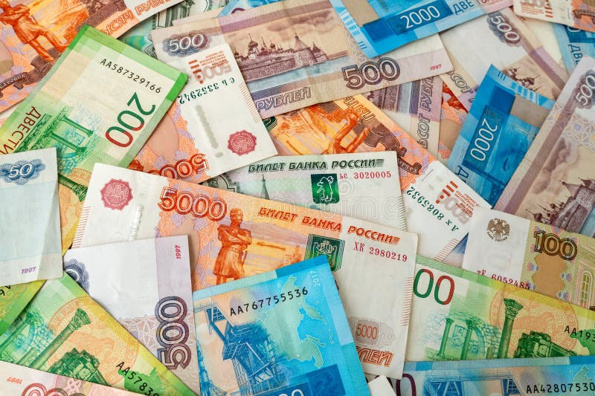
MONEY
In Russia, all transactions are conducted exclusively in Russian ruble

Cash rubles: the most reliable payment method
It is the only method accepted absolutely everywhere—from large chain stores to small shops and public transport.
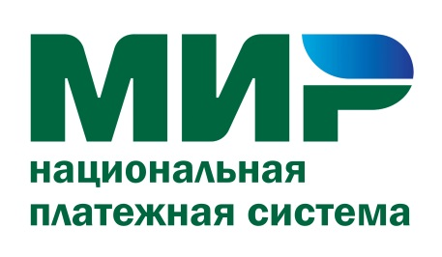
Cards of the Russian payment system "Mir"
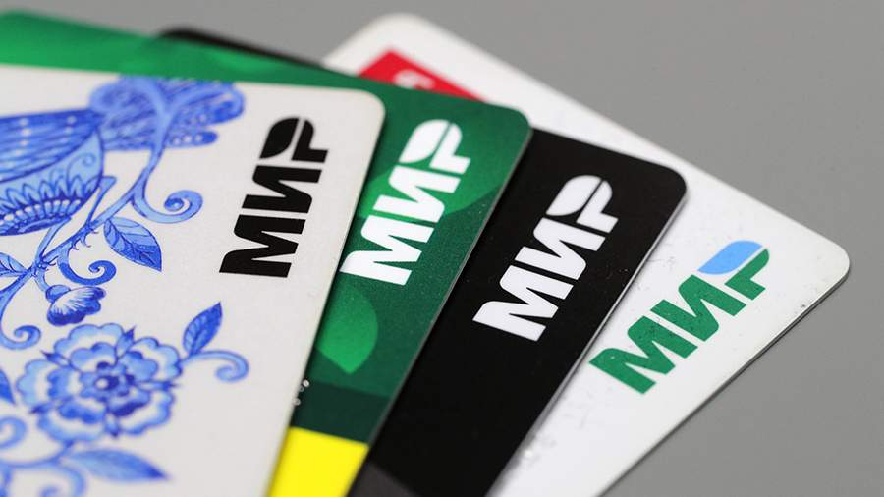
A foreign national can open an account at a Russian bank and obtain such a card using their passport.
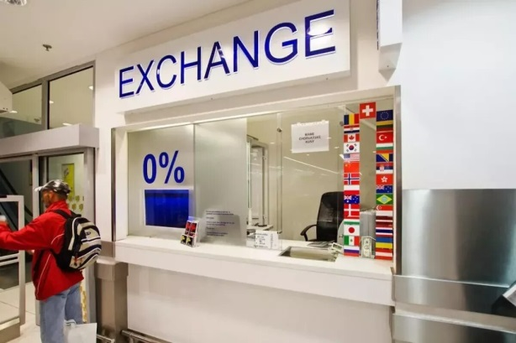
Currency Exchange
Foreign currency can be exchanged for rubles at any bank. You must have your passport with you.

