Fingerprint Registration and Photographing

For lawful stay in the Russian Federation, foreign students are required to undergo photographing and fingerprint registration within the established time limits.

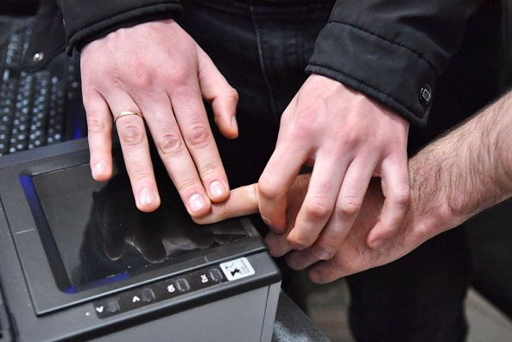

Legal basis: Federal Law No. 128-FZ “On State Fingerprint Registration in the Russian Federation.”

Who is required to undergo fingerprint registration

Foreign citizens who have arrived in the Russian Federation for a period of more than 90 calendar days, including students.

How often fingerprint registration must be undergone

Fingerprint registration and photographing are carried out by internal affairs bodies once, regardless of the number of entries into/exits from the Russian Federation.

Timeframe for Completion

• Within 90 calendar days from the day of entry into the Russian Federation.

Where to undergo fingerprint registration
Fingerprint registration is carried out at the territorial bodies of the Ministry of Internal Affairs of Russia at the place of stay:
Federal State Unitary Enterprise “Passport and Visa Service” of the Ministry of Internal Affairs of Russia for Volgograd Region, 94 Zemlyachki St., Volgograd. | 

Required documents for undergoing fingerprint registration

• passport of the foreign citizen;

• migration card;

• notification of registration for migration records (or another document confirming the address of stay);

• medical certificates.

Result of undergoing fingerprint registration
After undergoing fingerprint registration, the foreign citizen is issued a document confirming that the foreign citizen or stateless person has undergone mandatory state fingerprint registration and photographing. It is a laminated form (card) with a photograph and the holder’s identification data. | 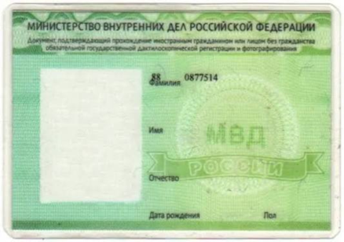

Consequences of Failure to Undergo  If the obligation to undergo fingerprint registration is not fulfilled, the issue of shortening the period of temporary stay in the Russian Federation will be considered in respect of foreign citizens. | 

If the document confirming completion of mandatory state fingerprint registration and photographing is lost or damaged, it is necessary to contact the migration division of the territorial body of the Ministry of Internal Affairs of Russia, where such document will be reissued.

