What is the Register of Controlled Persons?
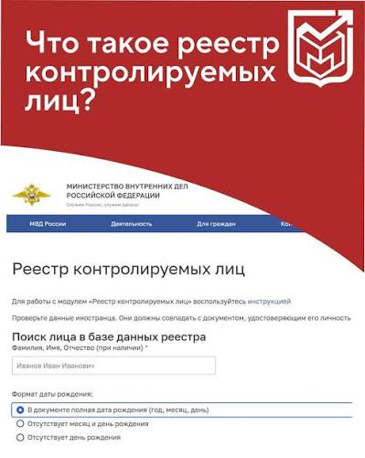

The Register of Controlled Persons (RKL) is an official database of the Russian Ministry of Internal Affairs that lists foreign nationals who have lost the legal grounds for staying in the Russian Federation. The register has been operational since February 5, 2025, hosted on the Russian Ministry of Internal Affairs website and the Gosuslugi portal.

Important: A citizen is deemed notified of their inclusion in the registry as of the date the information is posted on the official website of the Russian Interior Ministry.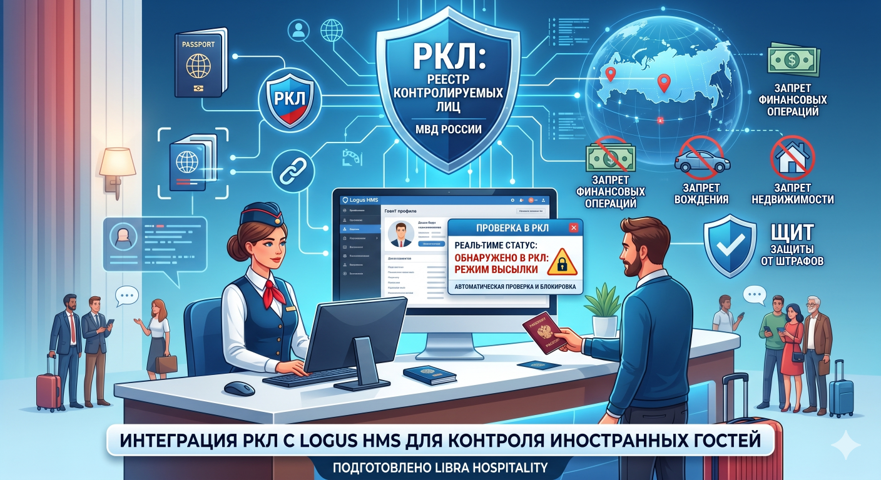

Grounds for inclusion in the registry:
• expiration of the authorized period of temporary stay (visa, migration card, temporary registration), temporary residence permit (RVP), temporary residence permit for education purposes (RVPO), or permanent residence permit (VNZh);
• reduction of the authorized period of temporary stay, or cancellation/revocation of a visa, RVP, RVPO, or VNZh;
• exceeding the established time limit for visa-free stay in the Russian Federation;
• denial or loss of refugee status;
• termination of Russian citizenship;
• imposition of an administrative penalty in the form of administrative expulsion;
• a decision has been made regarding deportation, readmission, undesirability of stay (residence), denial of entry, or restriction on exit;
• the state border of the Russian Federation has been crossed illegally;
• a court judgment of conviction for the commission of a crime has been issued.
A key ground for students: remaining in Russia for more than 90 days without valid authorization documents (a patent, work permit, temporary residence permit, or permanent residence permit) results in inclusion in the registry.

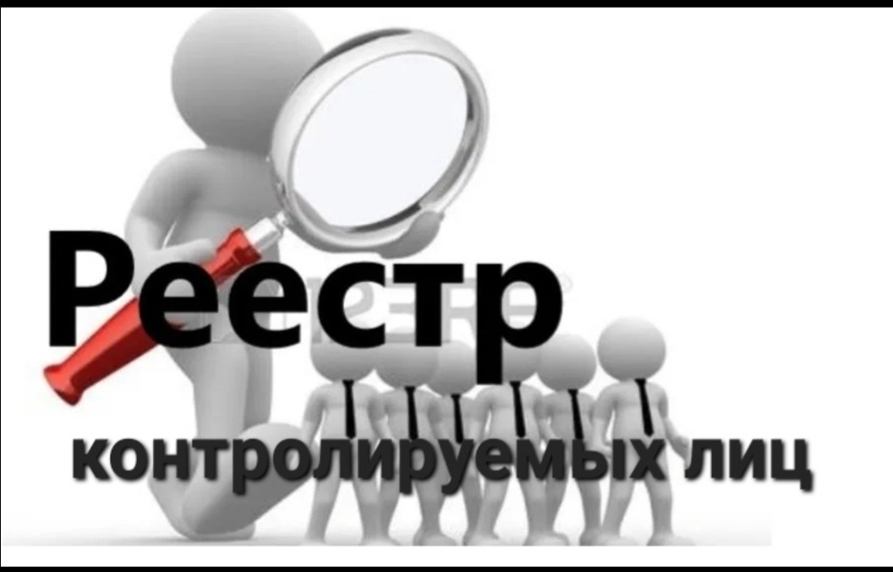
Foreign citizens included in the RKL are prohibited from:
- change one’s place of residence (or stay) without permission from the Ministry of Internal Affairs;
- travel outside the constituent entity of the Russian Federation where one is registered;
- purchase and register real estate or vehicles;
- operate a vehicle, be admitted to take driving tests, or obtain, replace, or exchange a driver’s license;заключать брак;
• establish a legal entity or register as an individual entrepreneur;
• open a bank account and conduct banking operations (except for transfers to the account of a controlled person and cash withdrawals exceeding 30,000 rubles per month).
The restrictions remain in effect until the individual fully regularizes their legal status or leaves the Russian Federation. Failure to comply with the rules inevitably leads to forced deportation.

How can I check my details in the registry?

You can check for your entry in the registry free of charge on two websites:
- The official website of the Russian Interior Ministry: https://мвд.рф/rkl;
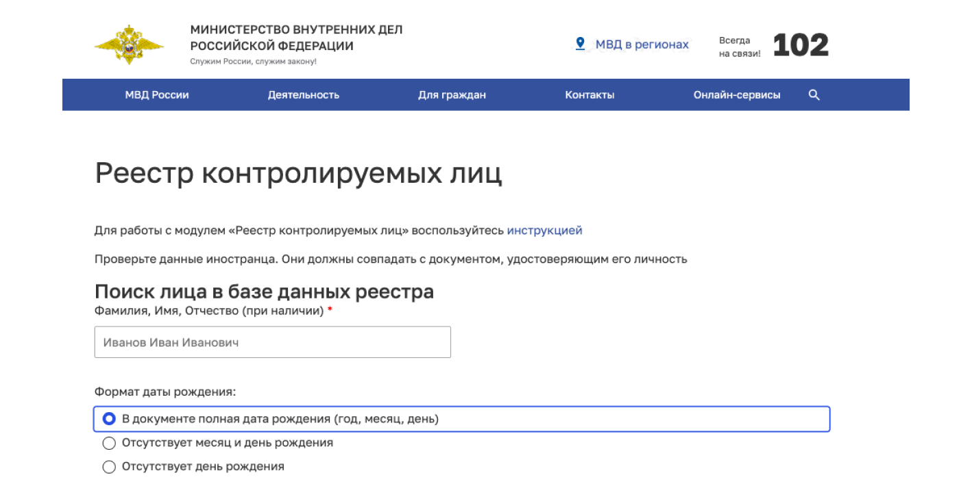

• Unified Portal of State and Municipal Services (Gosuslugi).
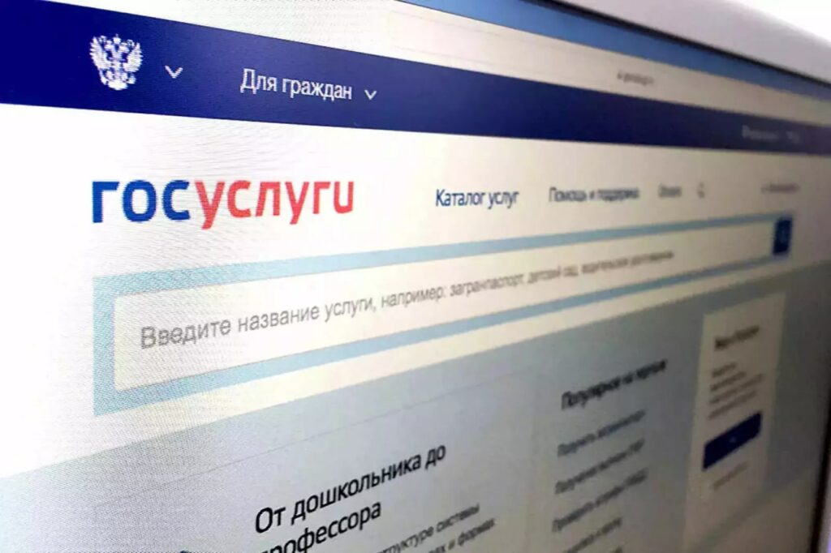

Enter your surname, first name, patronymic, date of birth, and the series, number, and date of issue of your identity document.

Important: Information is updated every 4 hours.

What should you do if you find yourself listed in the registry?

1. Contact the migration authorities.
• The Migration Department of the Main Directorate of the Ministry of Internal Affairs (MVD) for the region of your stay (specifically, the "Migration Department of the Main Directorate of the MVD of Russia for the Volgograd Region"; address: 10 Rokossovskogo Street, Volgograd);
• Branches of the FSUE "Passport and Visa Service" (PVS) of the Russian MVD (Volgograd branch of FSUE "Passport and Visa Service" of the Russian MVD; address: 94 Zemlyachki Street, Volgograd).

2. Fill out and sign the application for removal from the registry.
The application may be submitted in free-form format and must be accompanied by documents confirming the legality of your stay in Russia:
• Passport and a notarized translation;
• Valid migration card;
• Valid registration (migration registration);
• Proof of enrollment (certificate from the university, education contract);
• Temporary Residence Permit (RVP) or Permanent Residence Permit (VNZH) (if applicable);
• Employment contract (if applicable);
• Proof of fingerprinting and medical examination.

Grounds for removal from the registry:

1. Departure from the Russian Federation;

2. Acquisition of legal grounds for stay (obtaining a temporary residence permit, permanent residence permit, or work patent; visa extension);

3. Revocation of the decision that served as the basis for applying the expulsion regime;

4. Court ruling declaring the decision to include the individual in the registry unlawful;

5. Death of the foreign national.

Liability for organizations and individuals regarding those on the Register of Controlled Persons
Administrative fines are prescribed for providing services to persons included in the register of controlled persons:
• for individuals — from 2,000 to 5,000 rubles;
• for officials — from 35,000 to 50,000 rubles;
• for legal entities — from 400,000 to 500,000 rubles (Part 3 of Article 18.9 of the Code of Administrative Offenses of the Russian Federation).

