Temporary residence permit for the purpose of education
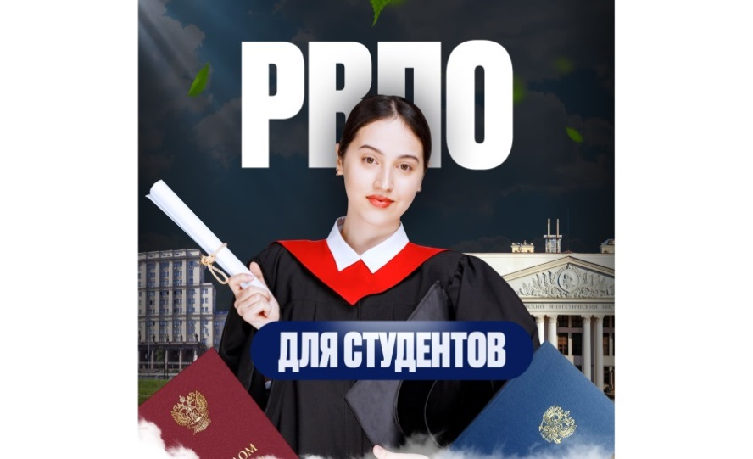 | A temporary residence permit for the purpose of education is a specific type of temporary residence permit for students enrolled in full-time study programs at Russian higher education institutions or research organizations.

Who is eligible to apply?
Foreign citizens studying full-time at a Russian state institution under one of the following programs:
• Bachelor’s degree;
• Specialist degree;
• Master’s degree;
• Medical residency;
• Assistantship-internship,
provided the institution holds state accreditation;
• Postgraduate training for research and academic-teaching personnel at a state educational or state scientific organization.
Where should the application be submitted?

To the territorial body of the federal executive authority in the sphere of internal affairs in the constituent entity of the Russian Federation where the studies are taking place.

What must be done before submitting the application?

Undergo a medical examination — at a medical facility authorized to conduct such examinations within the territory of the relevant constituent entity of the Russian Federation — to determine the presence or absence of: use of narcotic drugs or psychotropic substances without a doctor's prescription, or use of new potentially dangerous psychoactive substances; infectious diseases posing a danger to others (as specified in the list approved by the federal executive body authorized by the Government of the Russian Federation); and the disease caused by the human immunodeficiency virus. If the medical examination was completed in advance, the existing medical certificate must be valid for at least two months at the time of document submission.

Undergo mandatory state fingerprinting and photographing.

Key advantages of the temporary residence permit for the purpose of education
Validity period | Issued for the entire duration of studies plus 180 calendar days after completion.
Visa regime | It grants the right to obtain a multiple-entry visa valid for the entire duration of the temporary residence permit issued for the purpose of education (no annual renewal required).
Traveling abroad | It allows for continuous residence in Russia for the entire validity period of the temporary residence permit issued for the purpose of education.
Employment | Allows working throughout the Russian Federation without obtaining a separate patent or work permit.
Healthcare and Social Protection | It entitles the holder to obtain a compulsory medical insurance policy, which provides access to free medical care under the regional compulsory medical insurance program.
Path to a Residence Permit | Allows for the submission of documents for a residence permit within three years.
Reporting to the Ministry of Internal Affairs | It eliminates the need to annually notify the Ministry of Internal Affairs authorities to confirm residence in the Russian Federation.
Migration registration | Provides the option to register at the place of residence.

Documents for obtaining a temporary residence permit for the purpose of education

• Application: Appendix No. 4 to the Administrative Regulations of the Ministry of Internal Affairs of the Russian Federation on the provision of the state service for issuing temporary residence permits in the Russian Federation to foreign citizens and stateless persons for the purpose of education, approved by Order of the Ministry of Internal Affairs of Russia No. 949 dated December 14, 2022 (2 copies)—submitted in person or as an electronic document via the Unified Portal of State and Municipal Services;
• Applicant’s passport and a notarized translation of all passport pages;

• Two matte photographs (3.5 x 4.5 cm) showing a clear, full-face view without headgear;

• Police clearance certificate issued in the country of citizenship or at the embassy of the foreign national's country, along with a notarized translation (including seals);

• Medical documents confirming that the foreign national has undergone a medical examination;;

• Documents confirming student status:
• Certificate of enrollment;
• Extract from the enrollment order;
• Copy of the university license;
• Copy of the university accreditation certificate;

• Receipt of state fee payment;

• Notification of migration registration (registration at the place of stay);

• Migration card;

• Document confirming mandatory state fingerprint registration.

The following may be required:

• Birth, marriage, or name-change certificates;

• Documents confirming the foreign national's legal presence in the Russian Federation, including:
for those arriving under a visa regime – a visa;
for those arriving under a visa-free regime – a migration card;

• Documents confirming the degree of kinship (mandatory when applying for a permit for a foreign national under the age of eighteen).

Processing time for documents for the issuance of a temporary residence permit for the purpose of education

No more than 38 working days.

Please note!

• Submission timeline: It is recommended to submit your application no later than two months before your current visa or migration card expires.

• Criminal record certificate: This document is usually valid for three months. Ensure it is current on the day of submission.

• Translations: Translations of all passport pages must be certified by a notary authorized to certify translations.

• Medical certificates: Medical tests must be performed only at clinics accredited for migration-related purposes.

• Non-state universities: Non-state universities: Temporary residence permits for the purpose of education are granted only for studies at state institutions. If the university is private, please verify its accreditation.

What must you NOT do after obtaining a Temporary Residence Permit for educational purposes?

• Withdraw from the university or transfer to a correspondence or evening study program (if you lose your full-time student status, the Temporary Residence Permit for educational purposes will be revoked).

• Miss the deadlines for submitting documents to extend your place-of-residence registration (if you change your address, you must register at the new location).

• Take a job in violation of the Labor Code (a Temporary Residence Permit for educational purposes exempts you from the work patent requirement but does not exempt you from the requirement to sign a formal employment contract).

Grounds for refusal to issue or for the revocation of a temporary residence permit for the purpose of education
If a foreign national:

• advocates for the violent alteration of the foundations of the constitutional order of the Russian Federation, or otherwise poses a threat to the security of the Russian Federation or its citizens;

• finances or plans terrorist (extremist) acts, assists in the commission of such acts, or commits them, or otherwise supports terrorist (extremist) activity;

• within the five years preceding the date of submission of the application for the issuance of a temporary residence permit, was subject to administrative expulsion from the Russian Federation or deportation, or was transferred by the Russian Federation to a foreign state in accordance with an international readmission agreement of the Russian Federation; or, within the ten years preceding the date of submission of the application for the issuance of a temporary residence permit, was repeatedly (two or more times) subject to administrative expulsion from the Russian Federation or deportation, or was transferred by the Russian Federation to a foreign state in accordance with an international readmission agreement of the Russian Federation;

- submitted forged or falsified documents or provided knowingly false information about themselves;

- has been convicted by a final court judgment of committing a grave or especially grave crime, or of committing a crime related to the illicit trafficking of narcotic drugs, psychotropic substances and their analogues or precursors, or of plants containing narcotic drugs, psychotropic substances, or their precursors (including parts thereof containing such substances or precursors);

• has an unexpunged or unremoved criminal record for the commission of a grave or especially grave crime within the territory of the Russian Federation or outside it, if such crime is recognized as such in accordance with Federal Law;

- has repeatedly (two or more times) within a one-year period been held administratively liable for committing an administrative offense involving an encroachment on public order and public safety, or a violation of the rules governing the stay (residence) of foreign nationals in the Russian Federation or the procedures for their employment within the Russian Federation, or has committed an administrative offense involving the illicit trafficking of narcotic drugs, psychotropic substances and their analogues or precursors, or plants containing narcotic drugs, psychotropic substances, or their precursors, as well as parts thereof containing narcotic drugs, psychotropic substances, or their precursors;

• departed from the Russian Federation to a foreign state for permanent residence;

• was outside the Russian Federation for a total of more than six months during a calendar year, except in cases where it was impossible to leave the territory of a foreign state due to circumstances involving the need for emergency medical treatment, the foreign national’s serious illness, or the death of a close relative residing in that foreign state at the time of death, as well as cases where the foreign national was outside the Russian Federation due to work-related necessity;

• is a user of narcotic drugs or psychotropic substances without a medical prescription, or of new potentially dangerous psychoactive substances; or suffers from an infectious disease that poses a danger to others and is included in the list approved by the federal executive body authorized by the Government of the Russian Federation; or lacks a certificate confirming the absence of human immunodeficiency virus (HIV) infection; or has failed to submit the medical documents and certificate issued based on the results of a medical examination;

• submitted an application for the cancellation of the temporary residence permit issued to him;

• switched to a part-time or correspondence mode of study, or prematurely terminated his studies at an educational institution;

• in the event that a decision is made, in the prescribed manner, declaring the foreign citizen’s stay (residence) in the Russian Federation undesirable or denying them entry into the Russian Federation.

